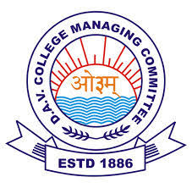

**DAV ACC Sr. Sec. Public School, LAKHERI**

**Date Sheet for 2nd Pre-Board Exam 2021-22**

**Timing** : 2:00pm to 3:00pm

|  |  |  |  |
| --- | --- | --- | --- |
| Date | Day | Class X | Class XII |
| 20-Jan.-2022 | Thursday | S. St. | Chemistry |
| 21-Jan.-2022 | Friday | Hindi | English |
| 22-Jan.-2022 | Saturday | English | IP / PHE |
| 24-Jan.-2022 | Monday | Maths | Biology/Maths |
| 25-Jan.-2022 | Tuesday | Science | Physics |

I/C Exam Co-ordinator PRINCIPAL

1. Examination mode : Online

2. Please collect OMR sheets from school office on or before 15/01/2022