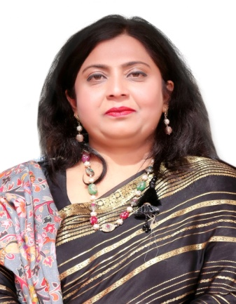

**I feel proud to be the Principal of RMB DAV School Nawanshahr. I always serve the institution with a healthy spirit & improve the quality of education. The art of teaching is to satisfy the curiosity of young minds. To promote a lifelong learning they need motivation and confidence. I along with my dedicated team promote the same. We teach them to be morally upright with Vedic culture and also to survive with the fast changing world. We provide them all the facilities at par with the best in the area. We arrange inter-class competitions to hunt their talent. We have a qualified and experienced staff that sharpens their knowledge by attending seminars & workshops. Our aim is to give our best to our students and work for their holistic development.**

**PRINCIPAL**

**RMB DAV CNTENARY PUBLIC SCHOOL**

**MUSAPUR ROAD, NAWANSHAHR**